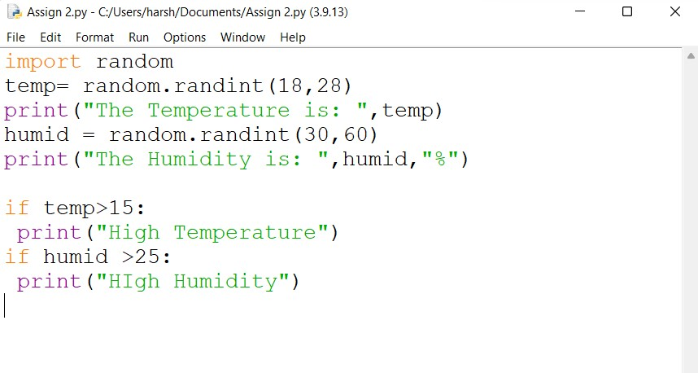**ASSIGNMENT 2**

|  |  |
| --- | --- |
| NAME | DHARANIKUMAR.B |
| DATE | 29/10/2022 |

CODE:

